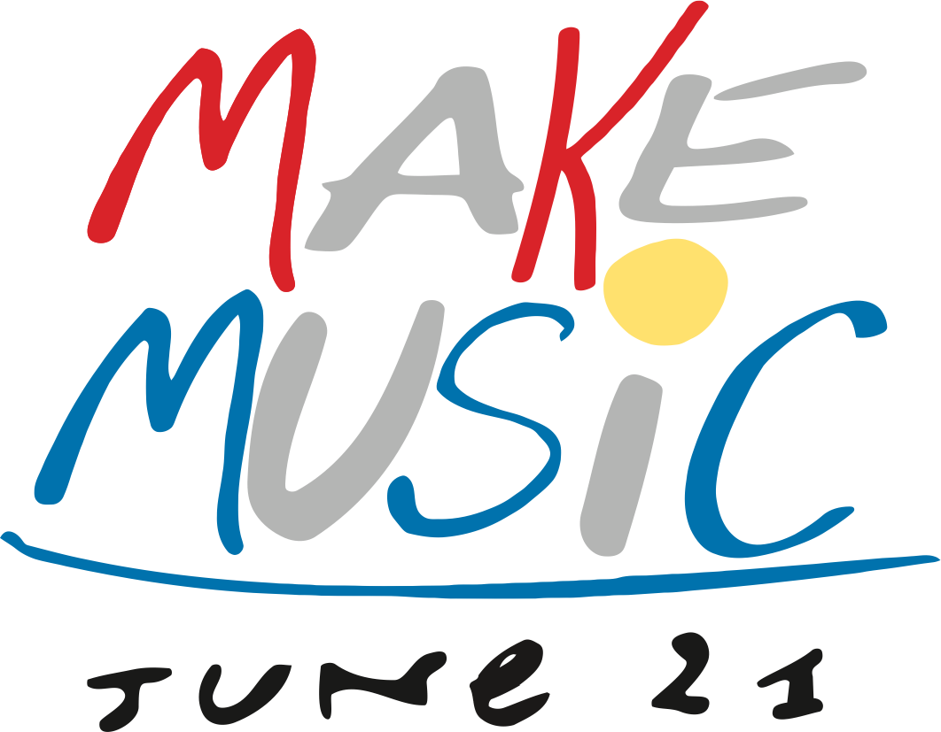

Join the worldwide celebration of music!
Sunday, June 21, 2015
www.makemusicday.org

TABLE OF CONTENTS

Section 1: The Make Music Movement: What is Make Music Day?

Section 2: How to Get Involved

Section 3: Publicize Your Event
- Publicity Timeline
- Press Release Template
- Media Advisory Template
- Recommended Social Media Posts

Section 4: Resources
- Websites
- Logos

Section 1: THE MAKE MUSIC MOVEMENT

Make Music Day is a worldwide, daylong celebration of free, public, outdoor music on the summer solstice.

Last year, organizers in over 800 cities around the world took part and reimagined their city as a stage. Musicians of all styles, all ages, and all skill levels used music to spread joy to their communities – on rooftops, in store fronts, in parks and porches – anywhere they dreamt of hosting a concert.

This movement started in France in 1982 with an event called Fête de la Musique (or "Make Music" in English). Today, it has become an international phenomenon, and hundreds of millions of people worldwide celebrate, create, and share music in public spaces on June 21st. It has recently gained momentum in North America, with nineteen cities participating last year, including “Make Music New York,” “Make Music Chicago” and “Make Music Madison.”

To learn more and to get involved, visit makemusicday.org

Why We Do It

The Make Music movement affirms the importance of music and its role in building and bridging communities – community members have cultural events brought to where they are, amateur musicians share their passion and gain confidence, and professionals are introduced to new audiences. It’s the perfect opportunity for your store or business to host an event and create more music makers. So tap your feet, grab an instrument, amp up and bring your community together in a worldwide celebration of music!

Who Participates?
More than 800 cities in 110 countries hold official, citywide celebrations of music on June 21st with free, openly accessible concerts, music lessons, and participatory performances.

On a smaller scale, many others around the world join in with their own events on June 21st, wherever they are, organizing music for their neighborhood, for their block, or for their parking lot.

If you want to start up a citywide celebration, there are resources to help you get started! You can find links to participating cities and ways to get started at makemusicday.org.

Citywide Make Music celebrations in 2015 will include:

Fullerton, CA
Los Angeles, CA
Seattle, WA
Santa Fe, NM
Plymouth, NH
Denver, CO
Portland, OR
Chicago, IL
Cambridge, MA
Portland, ME
Montclair, NJ
San Diego, CA
New York City, NY
Philadelphia, PA
Austin, TX
Issaquah, WA
Hoboken, NJ
Madison, WI
Vancouver, BC
Toronto, ON

Section 2: HOW TO GET INVOLVED
The best thing about Make Music Day is that anyone can perform, anyone can host, and any place can become a venue! June 21st concerts are free and open to the public.

To participate, start by contacting your local Make Music organizers. By visiting makemusicday.org you can find a comprehensive list of city organizers and ways to contact them via their own websites.

If an official Make Music organization does not yet exist in your hometown, you can still be involved in the worldwide celebration and easily create your own event! You can even establish a new branch based in your city or town. For advice and more information on getting involved, members can contact the NAMM Mass Appeal Fellow Dave Ruder, dave@makemusicday.org.

Create a Make Music Day Event Step-by-Step!
- REACH OUT TO ORGANIZERS
- Partner with a Make Music city and join an existing local organization; reach out to city contacts to collaborate with local organizers in promoting what you are doing as part of the overall, city-wide or regional events.
- Contact NAMM Make Mass Appeal Fellow Dave Ruder at dave@makemusicday.org if your community does not have a local branch to join the worldwide celebration on June 21st.

2. SECURE LOCATION
- If your city has Make Music Organizers, contact them directly about setting up your location as a participating venue or finding another space to partner with.
- If your city does not have Make Music Organizers, look into getting a permit for your outdoor, public Make Music Day event. Whether your event is on your storefront sidewalk or in a public park, be sure that you are complying with public safety laws. Contact dave@makemusicday.org for more information.
- Make Music Day concerts are free to attend and open to the public and can exist:
  - On store fronts, stoops, sidewalks, and streets
  - In parks, parking lots, plazas, and gardens
  - At schools, community centers, churches, and libraries

3. PLAN YOUR EVENT
- Invite your customers or a specific community group to participate in a public, hands-on, music-making event in your business or at a local park.
  - Gather together a Drum circle
  - Teach first time musicians how to play the ukulele or harmonica
  - Host a guitar strum-along for customers and community members
  - See makemusicday.org for more hands-on “Mass Appeal” ideas.
- Host a day of outdoor concerts for the lesson-taking students in your community.
  - Unite all of your flute players for a flute troop play along
  - Host a trumpet brigade fanfare
  - Create an outdoor String Suzuki Slam recital
- Create an instrument-making percussion event with young children.
  - Ask children to bring a coffee can and provide construction paper for decoration
  - Partner with a local hardware store for a hands-on percussion fun day
  - Create frame drums easily with packing tape and picture frames
- Hold a jam session. Invite customers, their friends, your employees, and the community as a whole to bring their musical instruments to your business for a Make Music Day jam session.
- Host a concert or a battle of the bands. Invite a school chorus, church group or other community band to perform at your business. You may already host these types of performances; by scheduling one on June 21st, you can broaden your reach by tapping into the resources of Make Music Day.

Section 3: PUBLIC RELATIONS TOOLS & TIPS

Hosting a Make Music Day event is a wonderful way to make music in your community and to raise awareness that music making is for everyone.

90 Days Out
Plan Your Event
- Create a Save the Date message and start thinking about the type of event you’ll hold (Section 2) and who will manage it.
- Decide on the resources needed to have a successful event.
- Partner with a nearby Make Music city, if available in your area.
- Download Make Music Day logos to promote June 21st activities.

30 Days Out
Publicize Your Event
- Create marketing collateral to promote your event. Post fliers in your business windows and promote the event(s) on your website
- Customize the press release template (page 6) for your event and email it to local TV, radio, blogs, newspapers, entertainment weeklies, local business and trade publications. Follow up with the key publications/writers by telephone in order to make sure it was received, and to answer any questions.
- Begin using social media channels to publicize your event to your customers, clients and social media followers. See suggested posts on page 8.

One Week Out
Continue Publicity Efforts
a) Customize the media advisory (page 7) for your store or event and send it to your local newspaper, radio and TV stations editor or photo editor by e-mail.
b) Call local media to make sure they received your media advisory and invite them to come to your business or event on June 21st to take a photo of your customers making music. Emphasize that the event is part of a national celebration of music making for both amateur as well as professional musicians, and how playing music benefits people of all ages.
c) Agree on a specific time that the photographer or reporter will come to your store or event on June 21st to cover your event. Ensure the editor is aware of all the event details (date, time, location).

Day of Event
Coordinate a Photo Shoot
- Take lots of pictures of your customers/community participating in your Make Music Day event and encourage everyone present to do the same.
- Have parents of participants under 18 sign the attached photo release form if the photos will be used for media (social or traditional).
- Ensure a designated spokesperson is well prepared to answer questions from the media.

After The Event
Conduct Follow-Up Publicity
- Send of few of your best event photos via email to the local media from your in pre-event efforts. Include the name of your business and the event, the date and occasion, a short description of the action in the photos, and any identifying information for those featured in the photos.
- Share media coverage and photo galleries from event via newsletters, website and social media

MEDIA CONTACT: <Insert Contact Name>
<Insert Name of Company>
<Insert Phone Number>
<Insert E-mail Address>

<Insert Name of Company> Celebrates Make Music Day with <Event>
<Town/community name> participates in global celebration
of making music on the longest day of the year

<CITY>, <State> (<Date>) — <Name of Company> joins the Make Music Day <If there is a local Make Music City event in your area, mention it here as well> celebration with a <Insert brief event description> on Sunday, June 21, 2015. Make Music Day is a one-day event where free, live musical performances, opportunities to make music and other musical events take place around the world on the longest day of the year. Musical festivities in <city/town> are part of a global celebration of music making in over 800 cities inspired by France’s Fête de la Musique.

<Name of Company> invites everyone from professional musicians to people who have never picked up an instrument to join in the global music celebration by attending <event.> <Insert details about event, place, time it begins and ends, and what participants can expect to see/hear/do.>

<Insert “QUOTE” from company spokesperson about Company’s participation in Make Music Day and how making music positively affects community.>

Music has been shown to strengthen social connectivity, reduce stress, lower blood pressure, stimulate memory, and is integral to a well-rounded, enjoyable life. By participating in Make Music Day, <Company> and <Town/Community> encourage every form of music making.

National Association of Music Merchants (NAMM) members and partners from coast to coast, including <Company>, will open their doors, joining in their communities’ celebrations of Make Music Day. June 21 is the perfect opportunity to stop in to a local music store for some gear or to go out and play – whether it’s for the first time or the thousandth.
###
About <Company>

About Make Music Day:
Make Music Day is held each year on June 21st, the summer solstice. Join the celebration by
visiting www.makemusicday.org

<Company> Celebrates Make Music Day with <Event>
<Free Event> brings global day of music to <town/community name>

WHAT: <Company> opens its doors for <event> in celebration of Make Music Day, a global event taking place in over 800 cities around the world. <Insert detail sentence about event (mention performers, music-making opportunities, etc).> Make Music Day is a day of music open to all in the streets, businesses, parks, and wherever people feel like playing or listening. <Company’s event> joins other events worldwide as communities come together in celebration of music and the countless benefits that making music brings.

WHO: <Company, Company tagline if needed, any involved community partners (for example, local performers, band, children’s group)>

WHEN: Make Music Day, Sunday, June 21, <TIME span>

WHERE: <Location, address, city>

WHY: <Company> celebrates Make Music Day to help circulate the myriad benefits of making music, and to offer community members a way to come together and to participate in the joys of music. <Insert simple sentence about Company’s commitment to music, the benefits of music, and service to the community>

By establishing one specific day each year, June 21st, to celebrate music, <company> encourages both amateur and professional music making, and empowers individuals to seek out ways to celebrate music in their community.

WHAT ELSE: For more information about <Company Event>, please contact <Phone, web address, etc.>

###
About <Company>

About Make Music Day:
Make Music Day is held each year on June 21st, the summer solstice. Join the celebration by
visiting www.makemusicday.org

RECOMMENDED SOCIAL MEDIA POSTS for promoting Make Music Day

For Facebook:
Join us on 6/21 for Make Music Day when we’ll INSERT EVENT DESCRIPTION.
Music unites. Join the movement!
*For image, share your music day event flyer

Rejoice, connect and inspire through the power of music! Join us on Sunday, 6/21 to celebrate Make Music Day <link to your event>
*For image, share inspirational music image

Save this date! Make Music Day is Sunday, June 21st…so tune your instruments and get ready to make a joyful noise with us! <link to your event>

Get ready to make some noise! Sunday, 6/21 is Make Music Day. Join the movement: http://bit.ly/MakeMusicDay
*Use image representative of your event or company

Will you be able to remember where you were on Make Music Day? Make it memorable. Join us on Sunday, 6/21 for <your event>: http://bit.ly/MakeMusicDay

(On June 21st) It’s Make Music Day! What will you play today?
<link to your event>
*Use Make Music Day logo

For Twitter:
Make Music Day is June 21st—join us & 800 cities around the world to #MakeMusic <link to your event>

Music unites us. Join the movement #MakeMusic http://bit.ly/MakeMusicDay

Come out & play at <your event> on the longest day of the year! #MakeMusic <link to your event>

Rejoice, connect & inspire through the power of music! Sunday, 6/21 at <@your business/event> #MakeMusic

Don’t get left out! Celebrate Make Music Day w/us at <@your business/event> #MakeMusic http://bit.ly/MakeMusicDay

“Music is an essential part of everything we do." –Legendary puppeteer Jim Henson. Join us on Make Music Day, June 21! #MakeMusic <link to your event>

On Sunday 6/21, the world is your stage. Celebrate Make Music Day! #MakeMusic http://bit.ly/MakeMusicDay

(On June 21st) It’s Make Music Day! Get out and play at <your event>! #MakeMusic http://bit.ly/MakeMusicDay

Section 4: RESOURCES
Websites:
Make Music Day - http://makemusicday.org/
NAMM - http://www.namm.org/news/articles/celebrate-make-music-day-june-21

Make Music Day Logo:

